BRIDGES International Missions Partnership Program Presents

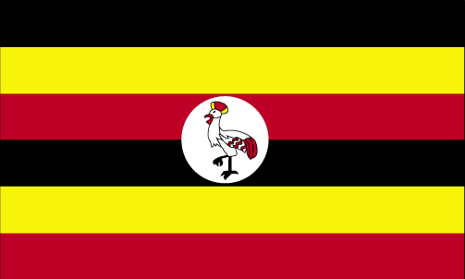

Uganda BRIDGE
Summer Internship Program

Sponsored by
The North Georgia Conference of the United Methodist Church
in partnership with the
United Methodist Volunteers in Mission (UMVIM)
http://www.ngumc.org/pages/detail/1613

A ten-week summer internship program for North Georgia United Methodist individuals interested in pursuing international immersion experiences in Christian mission, ministry, and education in Uganda, East Africa. APPLICATION DEADLINE: JAN. 27TH, 2012

Dates: May 24th to August 6th, 2012
(Dates are approximate, to be solidified in March. Will not shift more than 1 week.)

Eligibility: Adults (18 years or older) who have completed at least one year of college who hold membership in a local church within the North Georgia Conference of the United Methodist Church.

Applicants must also complete the enclosed application, and return it to:
Uganda BRIDGE Internship Program
c/o Rev. Blair Boyd Zant
86 Mt. Vernon Hwy
Sandy Springs, GA 30328.

Cost: $3,500-$4,000
Total includes airfare; travel visa; housing, meals, and program-related transportation; personal travel money; UMVIM Missionary Training, literature, and travel insurance.

Please see reverse side for more detailed information about this internship program.
The BRIDGES International Missions Partnership Program is the newest missions initiative from the North Georgia Conference of the UMC. Through BRIDGES, the NGC plans to pair with sister conferences around the world to cultivate opportunities for ministry, missions, service and learning that will strive to benefit churches and Christian believers on both sides of the partnerships.
In 2010, the NGC announced that the first BRIDGES partnership had been formed with the people and United Methodist churches of the East Africa Annual Conference, specifically in Uganda. Uganda is known as the “Pearl of Africa.” Its lush landscapes, proud people, and complex political and religious history create an incredible environment for international immersion and personal growth. In the summer of 2011, our inaugural class of interns learned this first-hand. We invite you to consider taking part in our next class.
The Uganda BRIDGE Summer Internship Program will offer participants the opportunity to live, learn and serve alongside Ugandan church and community leaders. Three different tracks have been crafted to offer interns tailored experiences in Church Ministry, Christian Education, or Agriculture, Theology, and Community Development.

- Church Ministry Track,
Mukono and Jinja Districts, United Methodist Church, East Africa Annual Conference

Interns will assist with the further development and growth of 1 to 2 United Methodist Churches in EAAC’s Mukono and Jinja Districts. Interns will participate in preaching, evangelism, Christian education, church development, outreach, pastoral care, and local church administration. Under the supervision of the local church pastors, District Superintendents, and the Bishop of the EAAC, interns will experience the blessings and challenges of local church development and leadership in Uganda.

- Christian Education Track,
Humble United Methodist School, Mukono, Uganda

Interns will work side by side with School administrators and teachers at HUMBLE United Methodist School. This unique school is sponsored by several UM Conferences in the United States, and provides a safe educational environment for vulnerable children. While most of the students are Ugandan, some also come from Rwanda, Sudan, Democratic Republic of Congo, and Burundi. Interns may work in the classroom, assist with office administration, work with and develop recreational, art, music, and/or drama programs, and assist as school chaplains, leading chapel services and devotionals for students.

- Agriculture, Theology, and Community Development Track
Humble United Methodist School, Mukono, Uganda

Interns will assist with the new agricultural initiatives at HUMBLE United Methodist School. Through hands-on experience cultivating, planting, tending and harvesting HUMBLE School’s new fields and gardens, Interns will be afforded opportunities to reflect on the ways that agricultural sustainability can positively affect communities, and where such initiatives cross-sect with Scripture and discipleship. This particular track could easily overlap with either of the other two, leaving room for additional participation in the life of the school, and/or the local church.

Interns will receive missionary training through the United Methodist Volunteers in Mission, will be supervised by Ugandan professionals in these fields, and offered spiritual reflection and vocational discernment with American and Ugandan pastors and supervisors.

Please contact Rev. Blair Zant, Program Coordinator, at blair.zant@ngumc.net, or 770-789-3731 with questions or for more information. For more information about BRIDGES, this Internship Program, and to download an application, visit http://www.ngumc.org/pages/detail/1613.

